CPE301 – FALL 2019

Design Assignment 4B

Student Name: Brysen Kokubun

Student #: 2001009068

Student Email: brysenkokubun96@gmail.com

Primary Github address: https://github.com/bkokubun99/Submission_DesignAssignments

Directory: <https://github.com/bkokubun99/Submission_DesignAssignments/tree/master/DesignAssignment_4B>

Submit the following for all Labs:

1. **COMPONENTS LIST AND CONNECTION BLOCK DIAGRAM w/ PINS**

Atmel Studio 7.0 Atmega328PB-Xmini PC MD08A StepMotor ServoMotor

- Assembler -Multifunction Shield -ULN2003AN

- Simulator -Bread Board

- Debugger

**Part 1** Step Motor (28BYJ-48)

**Part 2**  Servo Motor (3001HB)

1. **INITIAL/MODIFIED/DEVELOPED CODE OF TASK 1/A**

1. **DEVELOPED MODIFIED CODE OF TASK 2/A from TASK 1/A**

1. **SCHEMATICS**

**Part 1** (Step Motor)

**Part 2** (Servo Motor)

1. **SCREENSHOTS OF EACH TASK OUTPUT (ATMEL STUDIO OUTPUT)**

N/A

1. **SCREENSHOT OF EACH DEMO (BOARD SETUP)**

**Part 1** (Step Motor)

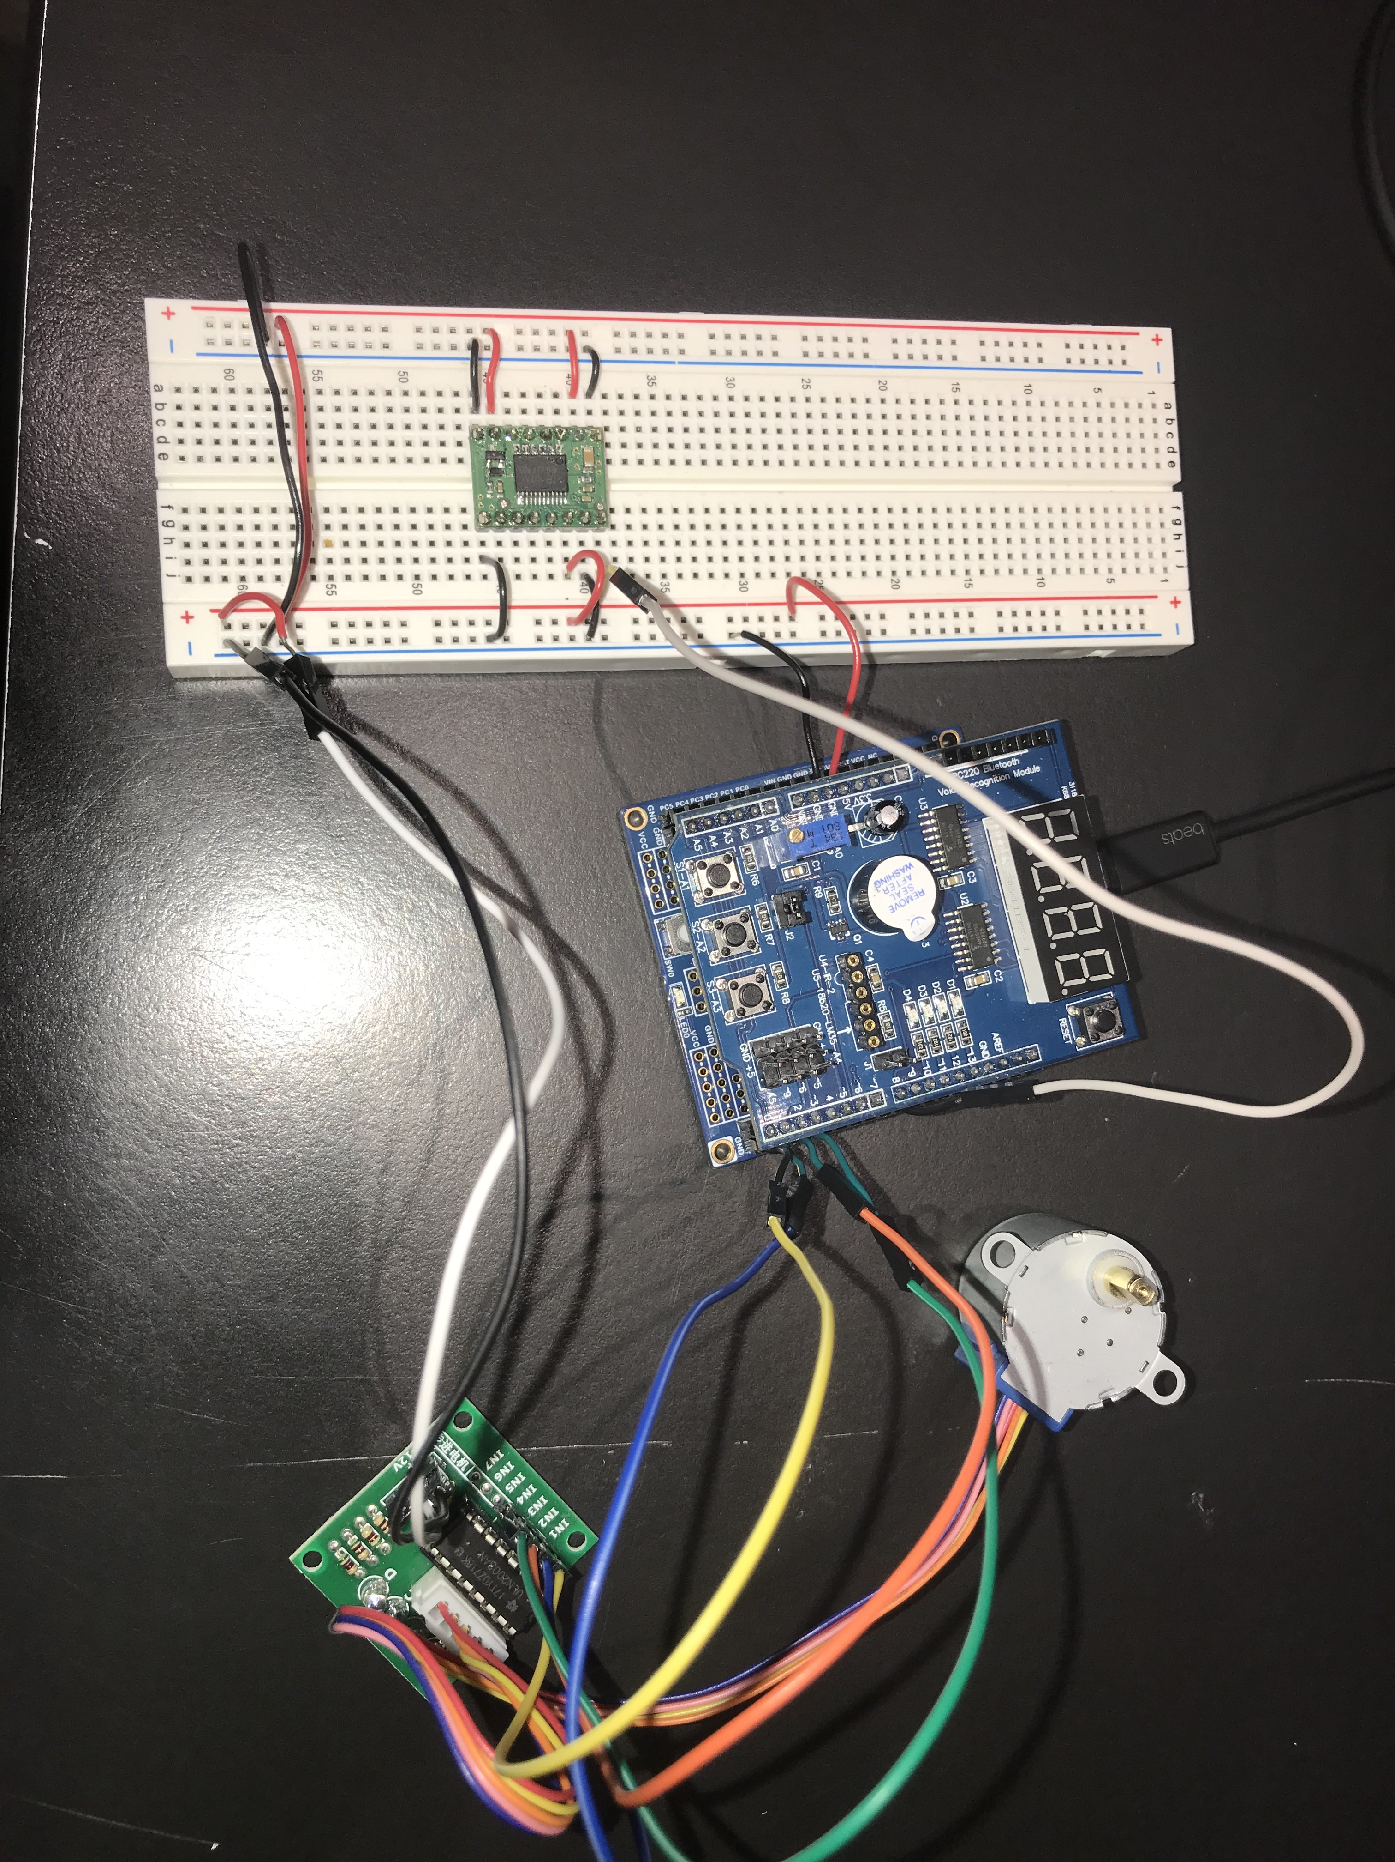

**Part 2** (Servo Motor)

1. **VIDEO LINKS OF EACH DEMO**

Part 1(Step Motor) YouTube Video Demo - <https://youtu.be/cl61q-k1Pdg>

Part 2(Servo Motor) YouTube Video Demo - <https://youtu.be/n6ruWBEreaM>

1. **GITHUB LINK OF THIS DA**

<https://github.com/bkokubun99/Submission_DesignAssignments/tree/master/DesignAssignment_4B>

**Student Academic Misconduct Policy**

<http://studentconduct.unlv.edu/misconduct/policy.html>

“This assignment submission is my own, original work”.

Brysen Kokubun